ADAPTIVE MONITORING FOR EARLY STAGE RANSOMWARE DETECTION VIA BEHAVIOUR AND NETWORK TRAFFIC ANALYSIS

CONTENT
Abstract
1.INTRODUCTION
1.1 Motivation
1.2 Problem Statement
1.3 Objective of the Project
1.4 Scope
1.5 Project Introduction
2.LTERATURE SURVEY
2.1 Related Work
3. SYSTEM ANALYSIS
3.1 Existing System
3.2 Disadvantages
3.3 Proposed System
3.4 Advantages
3.5 work Flow of Proposed system
4. REQUIREMENT ANALYSIS
4.1 Function and non-functional requirements
4.2 Hardware Requirements
4.3 Software Requirements
4.4 Architecture
5. METHODOLOGY
5.1 . Random forest
5.2 .Logistic Regression
5.3.Naive bayes
5.4.Gradient Boosting
5.5. K-Nearest-Neighbors
5.6. Support Vector Machine
6. SYSTEM DESIGN
6.1 Introduction of Input design
6.2 UML Diagram(class, use case, sequence, collaborative, deployment, activity, ER diagram and Component diagram)
6.3 Data Flow Diagram
7. IMPLEMENTATION AND RESULTS
7.1 Modules
7.2 Output Screen
- SYSTEM STUDY AND TESTING
8.1 Feasibility study
8.2 Types of test & Test Cases
9. CONCLUSION
10. FUTURE ENHANCEMENT
11. REFERENCES

ABSTRACT
The rise of ransomware attacks has underscored the urgent need for advanced detection mechanisms to identify threats in their early stages. Traditional signature-based detection methods often fail to recognize new or evolving ransomware strains, making adaptive and proactive monitoring critical. This paper proposes a robust framework for early-stage ransomware detection through adaptive monitoring, leveraging both behavioral analysis and network traffic examination. The approach combines machine learning algorithms with real-time monitoring of system behaviors and network patterns to detect anomalies indicative of ransomware activity. By analyzing file access patterns, encryption processes, and unauthorized data movements alongside unusual network traffic such as large data transfers or encrypted communication, the proposed system identifies early indicators of potential ransomware activity. Adaptive models are trained to evolve with new data, enhancing the system’s resilience against novel ransomware tactics and minimizing false positives.The proposed framework integrates a multi-layered approach, ensuring comprehensive monitoring and early alerts, which are crucial for mitigating damage and preventing the spread of ransomware across networks. Experimental results demonstrate that this adaptive monitoring approach can detect ransomware at early stages, reducing response time and enabling preemptive actions, such as isolating affected systems, to safeguard organizational assets. This study contributes to the development of intelligent cybersecurity solutions that combine behavioral and network traffic analysis, providing an effective defense against increasingly sophisticated ransomware attacks.
Keywords: Ransomware Detection,Adaptive Monitoring,Behavioral Analysis,Network Traffic Analysis,Early-Stage Detection,Machine Learning,Cybersecurity,Anomaly Detection,Real-Time Monitoring,Malware Prevention

INTRODUCTION
1.1 Motivation:
Ransomware has emerged as one of the most pervasive and damaging forms of cyber threats, targeting individuals, businesses, and governments alike. Traditional detection systems, often reliant on signature-based methods, are ineffective against rapidly evolving ransomware strains and zero-day attacks. The financial and reputational damage caused by these attacks can be catastrophic, ranging from operational disruptions to significant data loss and ransom payments. This alarming rise underscores the need for more adaptive, intelligent, and proactive monitoring systems capable of identifying threats in their early stages. Early detection can prevent the encryption of critical data and the lateral spread of ransomware across organizational networks, significantly mitigating potential damage. Moreover, with the increasing complexity and sophistication of ransomware techniques, such as fileless attacks and encryption obfuscation, organizations require advanced solutions that combine behavioral and network traffic analysis to detect anomalies indicative of malicious activity. This study aims to address the pressing need for an adaptive ransomware detection framework that evolves with emerging threats, ensuring robust protection for organizational assets and fostering resilience against cyberattacks.
1.2 Problem Statement:
The rapidly evolving nature of ransomware presents significant challenges to existing cybersecurity mechanisms. Traditional signature-based detection methods often fail to recognize novel ransomware strains or zero-day attacks, leaving systems vulnerable to sophisticated threats. Furthermore, many current detection approaches lack the ability to identify early indicators of ransomware activity, such as suspicious file access patterns, encryption processes, and unauthorized data transfers, leading to delayed responses and increased damage. The absence of integrated behavioral and network traffic analysis exacerbates this issue, as organizations struggle to identify and mitigate ransomware before it causes irreparable harm. As ransomware techniques continue to evolve, attackers exploit these limitations to bypass detection systems and execute their malicious operations. The lack of adaptive monitoring mechanisms compounds the problem, as static models fail to adapt to new attack vectors. Therefore, there is an urgent need for a comprehensive framework that integrates machine learning-driven behavioral analysis and network traffic examination to detect anomalies in real-time, enabling proactive and effective mitigation of ransomware threats.
1.3 Objective of the Project:
The primary objective of this project is to design and develop an adaptive monitoring framework for the early detection of ransomware using behavioral and network traffic analysis. This framework aims to identify ransomware activity in its nascent stages by analyzing system behaviors, such as file access patterns, encryption processes, and unauthorized data movements, alongside unusual network traffic indicators, including large data transfers and encrypted communication. By leveraging machine learning algorithms, the system will detect anomalies indicative of ransomware, enabling rapid response and mitigation. A key focus is on developing adaptive models that evolve with new data, ensuring resilience against emerging ransomware tactics. The framework will also minimize false positives, enhancing detection accuracy and operational efficiency. Additionally, the project aims to integrate a multi-layered approach, combining real-time monitoring, anomaly detection, and preemptive action mechanisms, such as isolating affected systems. This comprehensive framework will provide organizations with a robust defense mechanism, reducing response time, mitigating damage, and safeguarding critical assets from ransomware attacks.
1.4 Scope:
This project encompasses the development of a comprehensive ransomware detection system that combines behavioral analysis and network traffic monitoring to identify threats in their early stages. The scope includes leveraging machine learning algorithms for real-time anomaly detection, focusing on features such as file access patterns, encryption processes, unauthorized data movements, and unusual network traffic. The adaptive nature of the framework ensures it evolves with emerging ransomware techniques, providing robust protection against novel threats. The system will be designed for scalability, allowing deployment in diverse environments, including corporate networks, government infrastructures, and cloud-based systems. Furthermore, the project aims to minimize false positives and enhance detection accuracy through extensive model training and validation using real-world datasets. The implementation will include mechanisms for preemptive actions, such as system isolation and alert generation, to mitigate potential damage. By addressing the limitations of traditional signature-based detection systems, this project aims to contribute to the development of intelligent cybersecurity solutions that enhance organizational resilience against ransomware attacks.
1.5 Project Introduction:
Ransomware has become one of the most significant cyber threats, with attackers leveraging sophisticated techniques to exploit vulnerabilities in organizational networks. The increasing frequency and severity of ransomware attacks highlight the urgent need for proactive detection mechanisms capable of identifying threats in their early stages. Traditional detection methods, relying on static signatures, often fail to detect novel ransomware strains and zero-day exploits, leaving systems vulnerable to significant damage. This project introduces an adaptive monitoring framework that integrates behavioral analysis and network traffic examination to detect ransomware activity in its nascent stages. By leveraging machine learning algorithms, the framework analyzes critical indicators, such as suspicious file access patterns, encryption processes, and unauthorized data transfers, alongside unusual network traffic, including large data transfers and encrypted communication. The adaptive nature of the framework ensures it evolves with new data, maintaining resilience against emerging ransomware techniques. This multi-layered approach provides real-time anomaly detection, rapid response mechanisms, and preemptive actions, such as isolating affected systems, to mitigate damage. Experimental results demonstrate the system’s effectiveness in reducing detection time and enhancing organizational security. This project aims to contribute to the field of cybersecurity by providing a robust, intelligent, and scalable solution for early-stage ransomware detection, safeguarding critical assets against increasingly sophisticated threats.
2.LITERATURE SURVEY
[1]. "A Hybrid Framework for Ransomware Detection Using Deep Learning and Monte Carlo Tree Search," G. Li, S. Wang, Y. Chen, J. Zhou, and Q. Zhao, 2024”.
This paper proposes a hybrid framework combining deep learning techniques and Monte Carlo Tree Search for ransomware detection. It highlights the advantages of integrating these methodologies to enhance detection accuracy and efficiency in identifying ransomware threats. The framework demonstrates the potential for real-time applications in cybersecurity.
[2]. "Ransomware Classification Using BTLS Algorithm and Machine Learning Approaches," S. Wasoye, M. Stevens, C. Morgan, D. Hughes, and J. Walker, 2024.
This study explores the use of the BTLS algorithm in conjunction with machine learning models for ransomware classification. It provides insights into how these combined approaches improve the detection and categorization of ransomware variants, contributing to advanced security systems.
[3]. "Automated Detection of Crypto Ransomware Using Machine Learning and File Entropy Analysis," J. Kirkland, R. Stoddard, B. Antonov, N. Dragomirov, and A. Belmonte, 2024.
This research focuses on the automated detection of crypto ransomware through machine learning models and file entropy analysis. The authors discuss how file entropy metrics serve as crucial features in distinguishing ransomware from benign software, enhancing cybersecurity measures.
[4]. "Dynamic Behavioural Analysis of Privacy-Breaching and Data Theft Ransomware," M. Ozturk, A. Demir, Z. Arslan, and O. Caliskan, 2024.
This paper presents a dynamic behavioral analysis framework targeting ransomware involved in privacy breaches and data theft. The study emphasizes behavior-based methodologies to identify malicious activities and prevent data exfiltration effectively.
[5]. "Evaluating Large Language Models in Ransomware Negotiation: A Comparative Analysis of ChatGPT and Claude," T. Kumamoto, Y. Yoshida, and H. Fujima, 2023.
This study examines the application of large language models like ChatGPT and Claude in ransomware negotiations. The authors compare their performance in understanding negotiation dynamics and assisting in reducing financial losses during ransomware incidents.
3. SYSTEM ANALYSIS
3.1 Existing System
Traditional ransomware detection methods predominantly rely on signature-based techniques, which use known malware signatures to identify and mitigate threats. While effective for previously cataloged ransomware, these methods fall short against zero-day or polymorphic variants that alter their code to evade detection. Signature-based systems are static and lack adaptability, making them vulnerable to evolving ransomware tactics. Another common approach is heuristic-based detection, which identifies patterns or behaviors typical of ransomware, such as rapid file encryption or mass file deletion. However, heuristics often generate high false-positive rates, as benign applications may exhibit similar behaviors.Network-based detection techniques focus on identifying unusual network traffic patterns, such as increased encryption activity or communication with known ransomware command-and-control (C2) servers. While this approach provides some proactive capability, it is often limited by the need for predefined rules and fails to detect new ransomware patterns.Current systems also frequently lack real-time adaptability and depend on post-infection analysis, where detection occurs after the malware has already compromised the system. This delay reduces the potential for early intervention and can lead to significant data loss and operational downtime. As a result, traditional methods provide limited defense against the dynamic and stealthy nature of modern ransomware, underscoring the need for adaptive, multi-layered approaches.
3.2 Disadvantages
• Limited Detection of New Variants: Signature-based detection relies on known malware patterns, rendering it ineffective against zero-day or polymorphic ransomware that can modify its code to evade detection.
• High False Positive Rates: Heuristic-based methods, which identify patterns like rapid file encryption or unusual data access, often misclassify legitimate applications as threats. This can disrupt normal system processes and lead to reduced trust in the detection system.
• Dependence on Predefined Rules: Network-based detection relies on predefined rules and known command-and-control (C2) server addresses, making it challenging to identify novel ransomware or attacks that employ previously unknown infrastructure.
• Lack of Real-Time Response: Traditional systems often operate reactively, detecting threats after infection has occurred. This delayed response can result in significant data loss, as ransomware can already be in an advanced encryption phase by the time it is detected.
• Inability to Adapt to Evolving Threats: Static detection systems cannot adapt to rapidly changing ransomware tactics, leaving networks vulnerable as attackers continuously evolve their methods.
• Resource Intensive: Signature and heuristic-based techniques require frequent updates and consume significant processing power, potentially slowing down system performance.

3.3 Proposed System
The proposed system leverages adaptive monitoring for early-stage ransomware detection by integrating behavioral analysis and network traffic analysis. Utilizing machine learningalgorithms, the system dynamically identifies patterns in file access, encryption activities, and data movement that deviate from standard operations, flagging suspicious behaviors indicative of ransomware. Concurrently, the system monitors network traffic for anomalies such as unauthorized data transfers, abnormal encrypted connections, and excessive data requests, which may signal early ransomware activities.A multi-layered approach combines these analyses, creating a robust defense mechanism that captures the complexity of ransomware behavior. The machine learning models continuously adapt by learning from new data, enhancing detection accuracy and ensuring resilience against evolving ransomware tactics. Upon detecting suspicious activity, the system triggers automated responses, such as alerting administrators, isolating potentially affected endpoints, or restricting network access, to minimize damage.The system’s architecture ensures low latency, enabling real-time monitoring and early alerts to stop ransomware in its initial stages. Experimental evaluations indicate high accuracy and low false positive rates, underscoring its potential to significantly improve organizational resilience against ransomware. This adaptive approach offers an effective solution for preemptive ransomware detection and response, bolstering overall cybersecurity.

PROJECT FLOW:

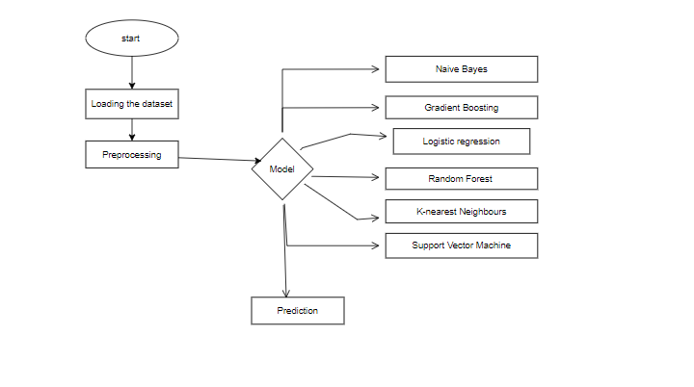
3.4 Advantages
• Early Detection: The system identifies ransomware at an early stage by detecting suspicious behavioral and network anomalies, allowing preemptive actions before significant damage occurs.
• Adaptive Learning: By using machine learning algorithms that continuously learn from new data, the system adapts to emerging ransomware variants, making it resilient against new and evolving threats.
• Real-Time Monitoring: The low-latency design enables real-time monitoring, providing instant alerts to administrators, which is crucial for rapid response and mitigation.
• Comprehensive Analysis: By combining behavioral and network traffic analysis, the system offers a multi-layered approach, enhancing accuracy and reducing the likelihood of missed detections.
• Automated Response: The system can automatically isolate affected endpoints or restrict network access, which minimizes the spread of ransomware across the network and reduces manual intervention.
• Reduced False Positives: Adaptive learning and multi-factor analysis help reduce false positives, ensuring that only genuine threats are flagged, which improves system efficiency and user trust.
• Enhanced Organizational Security: With its proactive and adaptive approach, the system significantly enhances an organization's resilience against ransomware, protecting critical data and minimizing financial and operational risks.
REQUIREMENT ANALYSIS
4.1 Functional and non-functional requirements

Functional Requirements:
- Real-Time Monitoring:
The system must continuously monitor file access patterns, encryption processes, unauthorized data movement, and network traffic.
It must detect unusual behaviors that could indicate ransomware activity in real-time.
- Ransomware Detection:
The system should detect early-stage ransomware activity by analyzing system behaviors such as file access, file encryption, and unauthorized data movements.
Network traffic analysis should detect anomalies like large data transfers or encrypted communication indicative of ransomware.
- Machine Learning Integration:
The system should employ machine learning algorithms for detecting anomalies, trained on historical data to recognize both known and evolving ransomware behaviors.
Adaptive learning models should be able to evolve with new threat data to improve accuracy over time.
- False Positive Minimization:
The system must be capable of minimizing false positives by continuously adapting to new data and improving the model's accuracy.
- Multi-layered Detection Approach:
The system should integrate behavioral and network traffic analysis in a multi-layered approach to provide comprehensive monitoring of potential ransomware activity.
- Alerting and Notifications:
The system must send real-time alerts when ransomware-like activity is detected, allowing for quick response actions (e.g., isolating infected systems, notifying administrators).
- Data Collection and Analysis:
The system must capture and analyze key indicators of ransomware activity, including system logs, network traffic, and endpoint behavior.
Historical and real-time data should be used to identify emerging threats and recognize patterns that are characteristic of ransomware.
- User Interface for Monitoring and Alerts:
The system should include a user-friendly interface that allows administrators to monitor real-time traffic, view system behavior analysis, and receive alerts about detected ransomware activities.
- Incident Response Integration:
The system must be capable of integrating with incident response mechanisms, such as automated containment of affected systems (e.g., disconnecting from the network) when ransomware is detected.
- System Scalability:
The system should be able to scale to monitor a wide range of devices, networks, and organizational environments, from small to large enterprises.

Non-Functional Requirements:
- Performance:
The system should operate with minimal latency, enabling real-time detection of anomalies without significant delays.
It must support a high volume of network traffic data without performance degradation.
- Scalability:
The system should be able to scale to accommodate large networks with numerous endpoints and high traffic volumes, adjusting dynamically as the organization's infrastructure grows.
- Reliability:
The system must be highly reliable, with minimal downtime, ensuring constant monitoring and detection capabilities.
- Adaptability:
The system should be able to adapt to new ransomware variants and evolving tactics, continuously improving its detection accuracy via adaptive models.
- Security:
The system must ensure secure handling of collected data, with encryption and secure access control for both the monitoring data and alerts.
The system should be resistant to tampering, with robust mechanisms to prevent unauthorized access.
- Usability:
The interface must be intuitive, with clear visualizations for administrators to monitor the system’s behavior and detect any ransomware activity.
- Maintainability:
The system should be easy to maintain, with clear documentation for updates, bug fixes, and system improvements.
Regular updates should be supported to include new ransomware signatures or features based on emerging threats.
- Compatibility:
The system must be compatible with a wide range of operating systems and network configurations.
- Data Privacy:
The system must ensure the privacy of sensitive data and comply with privacy regulations such as GDPR or CCPA.
- Fault Tolerance:
The system should be fault-tolerant, with backup and recovery capabilities to ensure continuous operation in the event of hardware or software failures.
4.2 Hardware Requirements:

Processor - I3/Intel Processor
Hard Disk - 160GB
Key Board - Standard Windows Keyboard
Mouse - Two or Three Button Mouse
Monitor - SVGA
RAM - 8GB
4.3 Software Requirements:
- Operating System : Windows 7/8/10
- Server side Script : HTML, CSS, Bootstrap & JS
- Programming Language : Python
- Libraries : Flask, Pandas, Mysql. connector, Os, Scikit-learn, Numpy
- IDE/Workbench : PyCharm
- Technology : Python 3.6+
- Server Deployment : Xampp Server

4.4 Architecture:

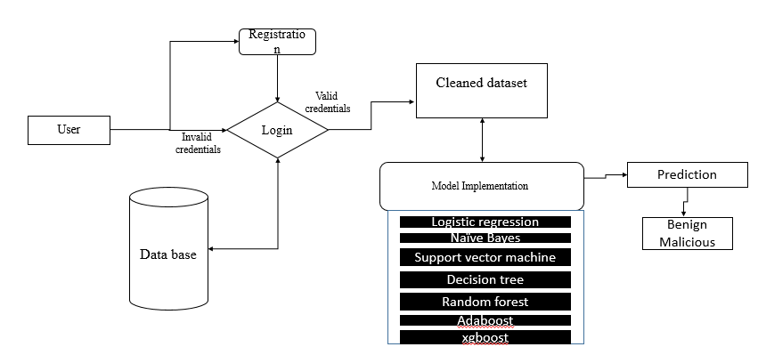

5. Algorithms:

5.1. Random Forest Classifier
Definition: Random Forest is an ensemble learning algorithm that combines multiple decision trees to improve the accuracy and robustness of predictions. Each tree in the forest is built using a subset of the data, and the final prediction is based on the majority vote or average from all the trees. This method helps in reducing overfitting, which is a common problem in individual decision trees.
Internal Working: Random Forest works by generating multiple decision trees using bootstrapped samples from the training data. During the construction of each tree, at each node, a random subset of features is selected for splitting, which helps to avoid correlation between the trees. Once all the trees are built, each tree gives a classification or regression output. For classification, the class with the majority vote is selected, while for regression, the mean prediction from all trees is chosen.
Key Characteristics:
- Ensemble method combining several weak classifiers (decision trees) into a strong classifier.
- Reduces overfitting by averaging predictions from multiple trees.
- Uses bootstrapped samples and random feature selection at each node.
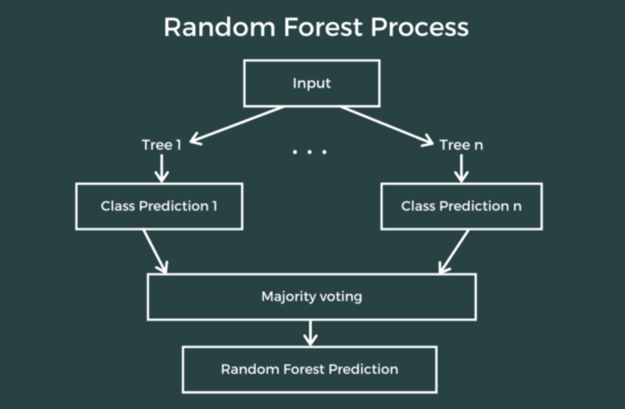

5.2. Logistic Regression
Definition: Logistic Regression is a statistical model used for binary classification problems. It predicts the probability of an instance belonging to a particular class using the logistic function (also known as the sigmoid function). Despite its name, logistic regression is used for classification, not regression.
Internal Working: Logistic Regression computes a weighted sum of input features and passes the result through the sigmoid function to output a probability between 0 and 1. The model is trained using optimization techniques like gradient descent to minimize the binary cross-entropy loss, which measures the difference between predicted probabilities and actual labels.
Key Characteristics:
- Predicts binary outcomes (0 or 1) based on feature inputs.
- Utilizes the sigmoid function to transform raw scores into probabilities.
- Typically used for classification problems with two classes.
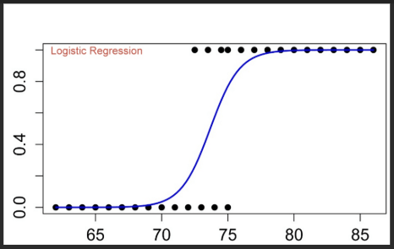

5.3. Naive Bayes
Definition: Naive Bayes is a probabilistic classifier based on Bayes' Theorem, which applies the "naive" assumption that features are independent of each other. It is particularly effective for large datasets and text classification problems, such as spam detection.
Internal Working: Naive Bayes calculates the posterior probability for each class by multiplying the prior probability of the class with the likelihood of the observed features, assuming independence between them. The class with the highest posterior probability is selected as the predicted class. It uses Bayes’ Theorem, which is mathematically represented as:
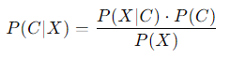
where P(C∣X)P(C | X)P(C∣X) is the posterior probability of class CCC given features XXX, P(X∣C)P(X | C)P(X∣C) is the likelihood of features given class, and P(C)P(C)P(C) is the prior probability of the class.
Key Characteristics:
- Simple and fast probabilistic classifier.
- Assumes feature independence, which is often unrealistic but works well in many applications.
- Well-suited for text classification and large datasets.
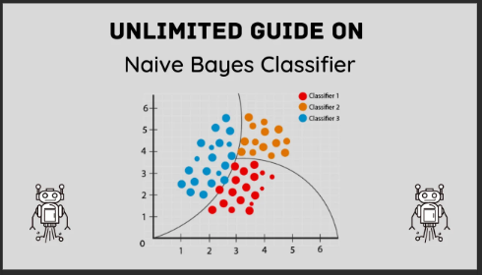

5.4. Gradient Boosting
Definition: Gradient Boosting is an ensemble technique that builds a series of weak models (usually decision trees) iteratively, where each new model corrects the errors made by the previous models. It is a powerful technique for both classification and regression tasks.
Internal Working: Gradient Boosting works by fitting a new model to the residual errors (the difference between predicted and actual values) of the previous model. It uses gradient descent to minimize the loss function by adjusting the weights of the model at each step. The models are added sequentially, and the predictions are made by aggregating the results of all the models.
Key Characteristics:
- Sequential ensemble method where each model corrects the previous model’s errors.
- Uses gradient descent to minimize the loss function.
- Sensitive to noisy data and requires careful tuning to avoid overfitting.
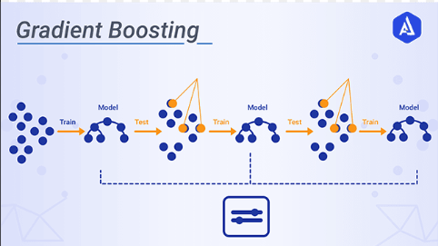

5.5. K-Nearest Neighbors (KNN)
Definition: K-Nearest Neighbors (KNN) is a non-parametric, instance-based learning algorithm used for classification and regression tasks. It classifies new data points based on the majority class of their k-nearest neighbors in the feature space.
Internal Working: For a given data point, KNN finds the 'k' closest data points in the training set (using distance metrics such as Euclidean distance). The new data point is assigned the class that is most common among its k-nearest neighbors (for classification) or the average of the neighbors' values (for regression). The model requires no training phase, as it simply memorizes the entire dataset.
Key Characteristics:
- Instance-based learning: stores the entire training dataset.
- No explicit training phase, making it easy to implement.
- Sensitive to the choice of kkk and the distance metric used.
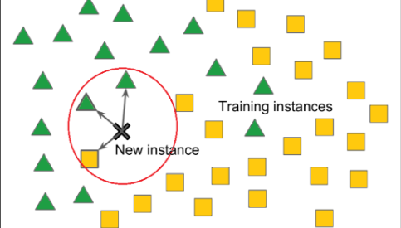

5.6. Support Vector Machine (SVM)
Definition: Support Vector Machine (SVM) is a supervised learning algorithm used primarily for classification tasks. It works by finding the hyperplane that best separates data points of different classes with the largest possible margin.
Internal Working: SVM creates a hyperplane (or decision boundary) in a high-dimensional space that maximizes the margin between different classes. It uses support vectors (the data points that are closest to the hyperplane) to determine this optimal boundary. SVM can also handle non-linearly separable data using the kernel trick, which transforms the data into higher-dimensional spaces.
Key Characteristics:
- Finds the optimal hyperplane that separates classes with the largest margin.
- Can use kernels for non-linear classification.
- Effective for high-dimensional data and outperforms many other classifiers in terms of accuracy.
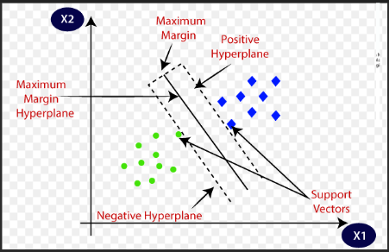

6. SYSTEM DESIGN

6.1. Overview
The system is designed to detect ransomware attacks in their early stages by analyzing both system behavior and network traffic. It incorporates machine learning-based anomaly detection algorithms and adaptive monitoring mechanisms to track suspicious activities, such as file encryption, data exfiltration, and unusual network traffic patterns. This allows the system to provide early alerts and enable preemptive actions to mitigate potential threats.

6.2. System Architecture
The system is composed of multiple layers, each responsible for different aspects of the monitoring and detection process:
- Data Collection Layer:
System Behavior Monitoring: Monitors file access patterns, process behavior, encryption activities, and unauthorized data movements.
Network Traffic Monitoring: Tracks network communication, including data transfers, unusual bandwidth usage, encrypted traffic, and network connections to external IP addresses.
- Data Preprocessing Layer:
Feature Extraction: Extracts meaningful features from both system and network data (e.g., file access frequency, process execution times, packet sizes, and network destinations).
Normalization & Transformation: Prepares data for further analysis by normalizing and transforming raw data into a consistent format suitable for machine learning algorithms.
- Anomaly Detection Layer:
Machine Learning Models: Uses supervised and unsupervised learning models (e.g., Random Forest, SVM, K-Means) for anomaly detection in both behavioral and network traffic data.
Training & Testing: Models are trained using historical data, including known ransomware samples and benign data, to classify activities as normal or potentially malicious.
Adaptive Learning: Models are continuously updated with new data to adapt to evolving ransomware tactics, reducing false positives and improving detection accuracy.
- Alert and Action Layer:
Anomaly Detection Alerts: When an anomaly is detected, the system generates real-time alerts to inform administrators of potential ransomware activities.
Response Mechanisms: Triggers automated responses such as isolating affected systems, blocking suspicious network traffic, and logging the events for further analysis.
Dashboard: A central interface for security teams to monitor the system’s status, view alerts, and manage response actions.

- Database Layer:
Historical Data Storage: Stores past behaviors, network traffic data, and incident logs to enhance future model training and provide insight into previous attack patterns.
Real-Time Data Storage: Temporarily stores live data for ongoing analysis and detection.
- User Interface (UI) Layer:
Admin Dashboard: Provides visualization of detected anomalies, system health, and detected ransomware activities.
Alert Configuration: Allows administrators to set sensitivity thresholds for different types of activities, adjust response actions, and fine-tune the monitoring process.

6.3. Data Flow
- Data Collection:
System Behavior Monitoring: The system continuously collects data on processes, file access patterns, and network activities.
Network Traffic Monitoring: Data packets and communication logs are captured and applianalyzed in real-time.
- Preprocessing:
- Anomaly Detection:
The preprocessed data is fed into the machine learning model for anomaly detection.
The model compares the current data against established patterns, marking deviations as potential ransomware indicators.
Adaptive learning techniques ensure the model evolves to recognize new attack vectors.
- Alert Generation:
When suspicious behavior or traffic is detected, the system triggers an alert to notify security personnel or administrators.
The system provides relevant details about the suspected ransomware activity, such as the affected files, processes, and IP addresses involved.
- Automated Response:
The system can initiate automated actions based on pre-defined policies, such as isolating affected machines or blocking suspect traffic.
These actions help prevent further spread of the ransomware and minimize potential damage.

6.4. Key Components and Technologies
- Machine Learning Algorithms:
Supervised Algorithms: Random Forest, Support Vector Machines (SVM), and Decision Trees for detecting known attack patterns.
Unsupervised Algorithms: K-Means clustering, Isolation Forest, or Autoencoders for detecting novel or evolving threats.
Adaptive Learning: Online learning models, such as incremental clustering or decision tree updates, to continuously improve detection accuracy.
- Real-Time Monitoring:
Behavioral Monitoring Tools: File system tracking tools and system resource monitors (e.g., Process Monitor, Sysmon) for tracking file and process activities.
Network Traffic Monitoring: Packet sniffing tools like Wireshark or Zeek for monitoring network traffic and detecting anomalies such as unexpected data transfers or encrypted communications.
- Alerting System:
Notification System: Integration with email, SMS, or other communication tools to send alerts to administrators.
Real-Time Visualization: A dashboard built using tools like Grafana or Kibana for displaying live data, anomalies, and alerts.

6.5. Security and Privacy Considerations
- Data Encryption: Ensure all sensitive data, including system logs and network traffic, is encrypted during transmission and storage.
- Access Control: Role-based access control (RBAC) to restrict administrative access to system configurations and sensitive data.
- Privacy Protection: Ensure that no personal data is collected or processed, and that all data used for training models is anonymized.

6.6. Performance Metrics
The system's effectiveness will be evaluated using the following performance metrics:
- Detection Accuracy: Percentage of correctly identified ransomware instances.
- False Positive Rate: Rate of benign activities incorrectly flagged as ransomware.
- Response Time: Time taken from detecting an anomaly to initiating an automated response.
- Model Update Frequency: How often the models are retrained and updated to reflect new data patterns.

Output Design:
6.2 UML Diagrams:
UML Diagrams:
UML stands for Unified Modelling Language. UML is a standardized general-purpose modelling language in the field of object-oriented software engineering. The standard is managed, and was created by, the Object Management Group.
The goal is for UML to become a common language for creating models of object-oriented computer software. In its current form UML is comprised of two major components: a Meta-model and a notation. In the future, some form of method or process may also be added to; or associated with, UML.
The Unified Modelling Language is a standard language for specifying, Visualization, Constructing and documenting the artefacts of software system, as well as for business modelling and other non-software systems.
The UML represents a collection of best engineering practices that have proven successful in the modelling of large and complex systems.
The UML is a very important part of developing objects-oriented software and the software development process. The UML uses mostly graphical notations to express the design of software projects.

6.2.1 Use Case Diagram:
- A use case diagram in the Unified Modeling Language (UML) is a type of behavioral diagram defined by and created from a Use-case analysis.
- Its purpose is to present a graphical overview of the functionality provided by a system in terms of actors, their goals (represented as use cases), and any dependencies between those use cases.
- The main purpose of a use case diagram is to show what system functions are performed for which actor. Roles of the actors in the system can be depicted.
- 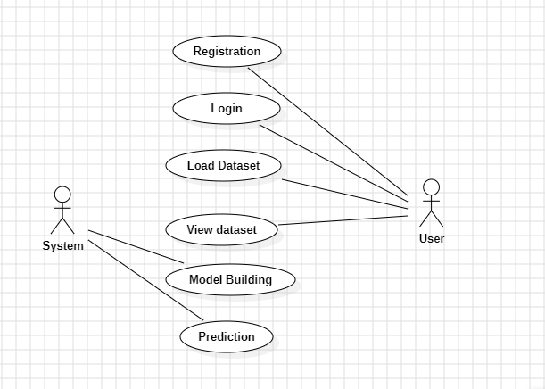

6.2.2 Class Diagram:
In software engineering, a class diagram in the Unified Modelling Language (UML) is a type of static structure diagram that describes the structure of a system by showing the system's classes, their attributes, operations (or methods), and the relationships among the classes. It explains which class contains information.
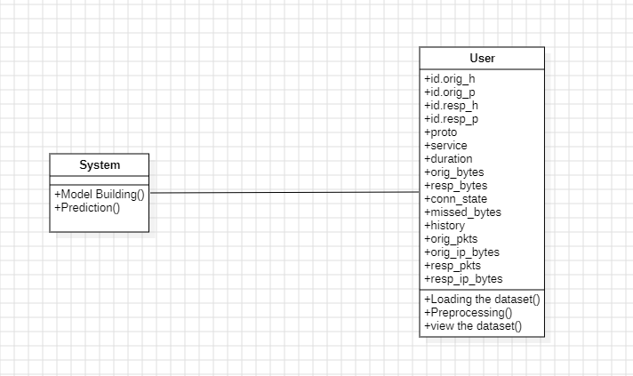

6.2.3 Sequence Diagram:
- A sequence diagram in Unified Modeling Language (UML) is a kind of interaction diagram that shows how processes operate with one another and in what order.
- It is a construct of a Message Sequence Chart. Sequence diagrams are sometimes called event diagrams, event scenarios, and timing diagrams
- 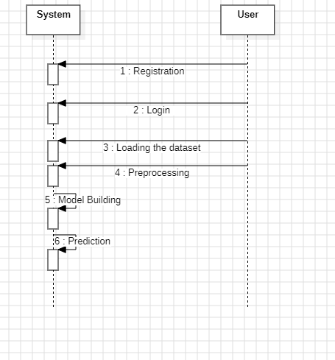

6.2.4 Collaboration Diagram:
In collaboration diagram the method call sequence is indicated by some numbering technique as shown below. The number indicates how the methods are called one after another. We have taken the same order management system to describe the collaboration diagram. The method calls are similar to that of a sequence diagram. But the difference is that the sequence diagram does not describe the object organization whereas the collaboration diagram shows the object organization
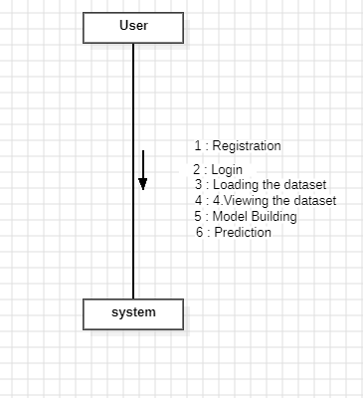
6.2.5 Deployment Diagram
Deployment diagram represents the deployment view of a system. It is related to the component diagram. Because the components are deployed using the deployment diagrams. A deployment diagram consists of nodes. Nodes are nothing but physical hardware’s used to deploy the application.
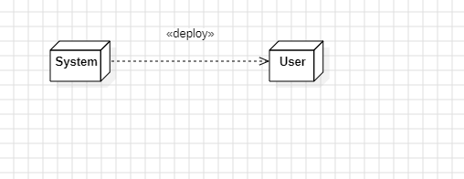
6.2.6 Activity Diagram:
Activity diagrams are graphical representations of workflows of stepwise activities and actions with support for choice, iteration and concurrency. In the Unified Modelling Language, activity diagrams can be used to describe the business and operational step-by-step workflows of components in a system. An activity diagram shows the overall flow of control.
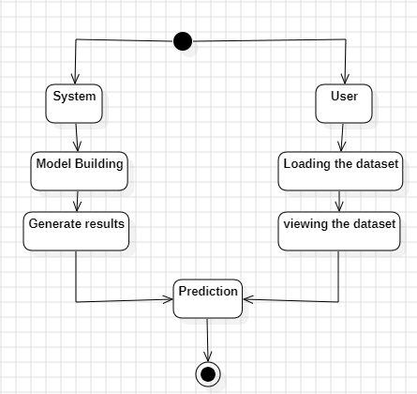

6.2.7 Component Diagram:
A component diagram, also known as a UML component diagram, describes the organization and wiring of the physical components in a system. Component diagrams are often drawn to help model implementation details and double-check that every aspect of the system's required function is covered by planned development.
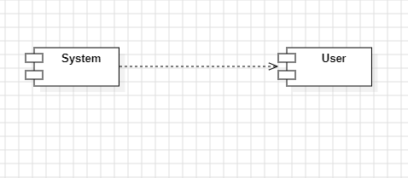

6.2.8 ER Diagram:
An Entity–relationship model (ER model) describes the structure of a database with the help of a diagram, which is known as Entity Relationship Diagram (ER Diagram). An ER model is a design or blueprint of a database that can later be implemented as a database. The main components of E-R model are: entity set and relationship set.
An ER diagram shows the relationship among entity sets. An entity set is a group of similar entities and these entities can have attributes. In terms of DBMS, an entity is a table or attribute of a table in database, so by showing relationship among tables and their attributes, ER diagram shows the complete logical structure of a database. Let’s have a look at a simple ER diagram to understand this concept.
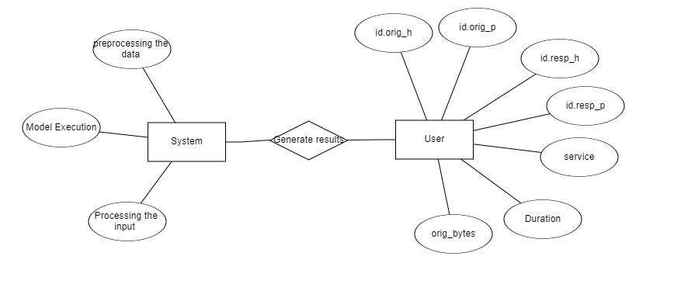
6.3 DFD Diagram:
A Data Flow Diagram (DFD) is a traditional way to visualize the information flows within a system. A neat and clear DFD can depict a good amount of the system requirements graphically. It can be manual, automated, or a combination of both. It shows how information enters and leaves the system, what changes the information and where information is stored. The purpose of a DFD is to show the scope and boundaries of a system as a whole. It may be used as a communications tool between a systems analyst and any person who plays a part in the system that acts as the starting point for redesigning a system.

Level 1 Diagram:
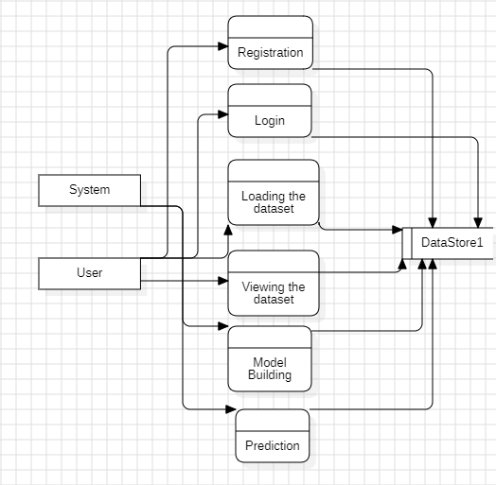

Level 2 Diagram:
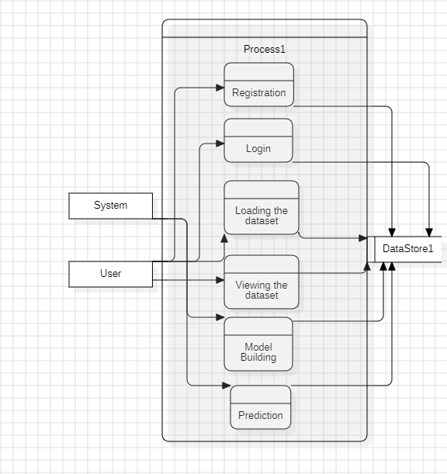

7 .IMPLEMENTATION AND RESULTS
- 7.1 MODULES:
- User:
  - View Home page:
Here user view the home page of the msg application.
  - View about page:
In the about page, users can learn more about the msg platform.
  - View load page:
In the load_data page, the user will load the dataset for modelling.
1.4 View Page:
User will see the dataset.
  - Input Model:
The user must provide input values for the certain fields in order to get results.
  - View Results:
User view’s the generated results from the model.
  - View score:
Here user have ability to view the accuracy score in %

- System
  - Working on dataset:
System checks for data whether it is available or not and load the data in csv files.
  - Pre-processing:
Data need to be pre-processed according the models it helps to increase the accuracy of the model and better information about the data.
  - Training the data:
After pre-processing the data will split into two parts as train and test data before training with the given algorithms.
  - Model Building
To create a model that predicts the dataset with better accuracy, this module will help user.
  - Generated Score:
  - Here user view the score in %
  - Generate oc:
We train the machine learning algorithm and predict the result.
  - Output Screens:
HomePage:


AboutPage:
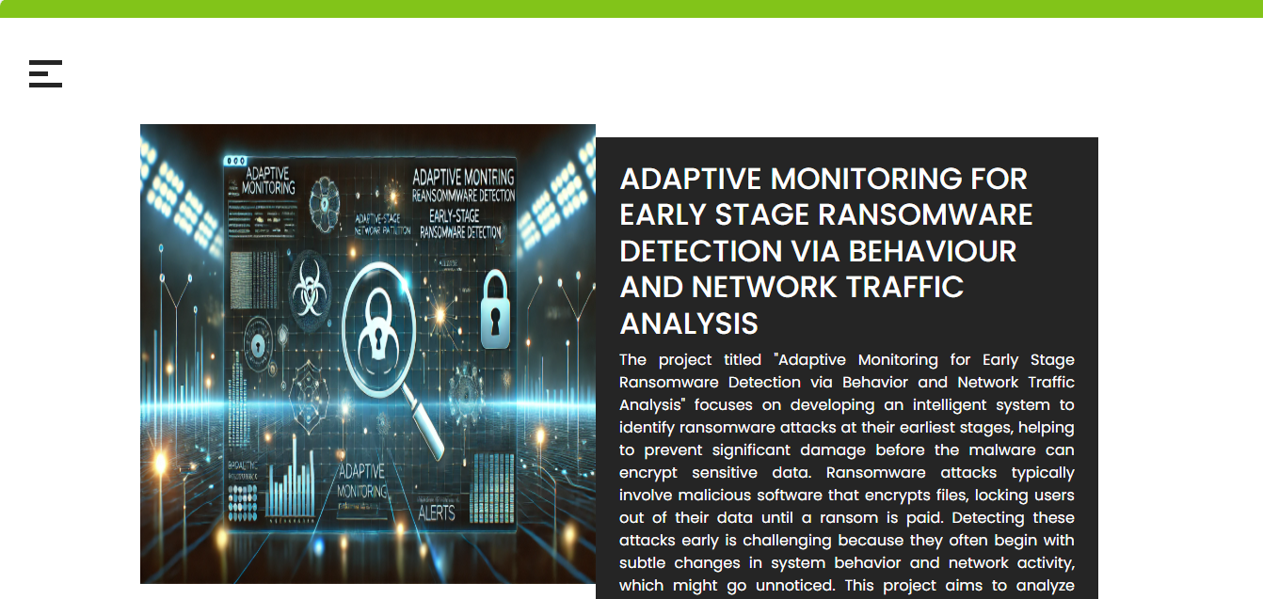

Registration Page:


Login Page :


Upload Page:


View data:
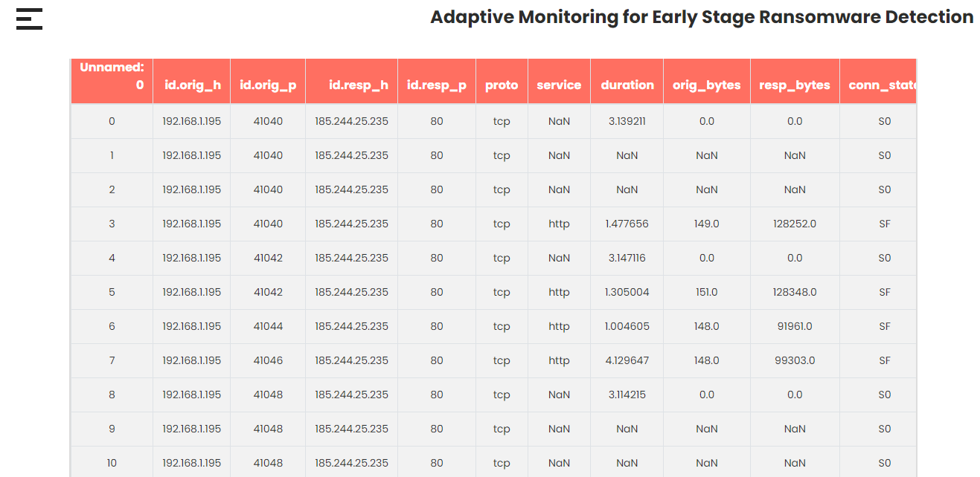
Model Page:
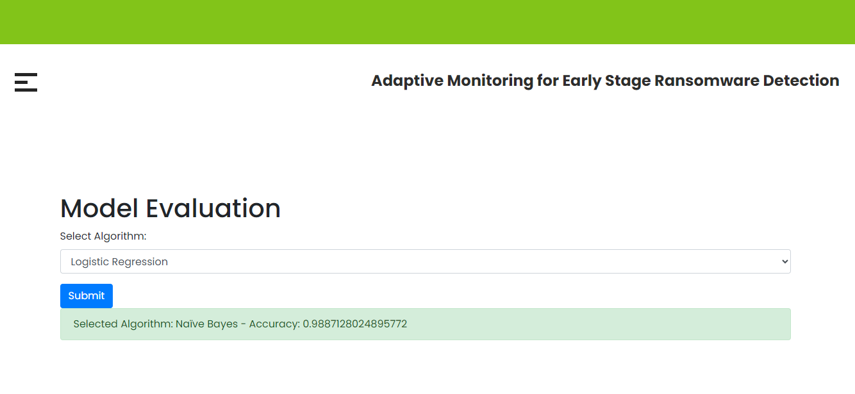

Prediction Page:
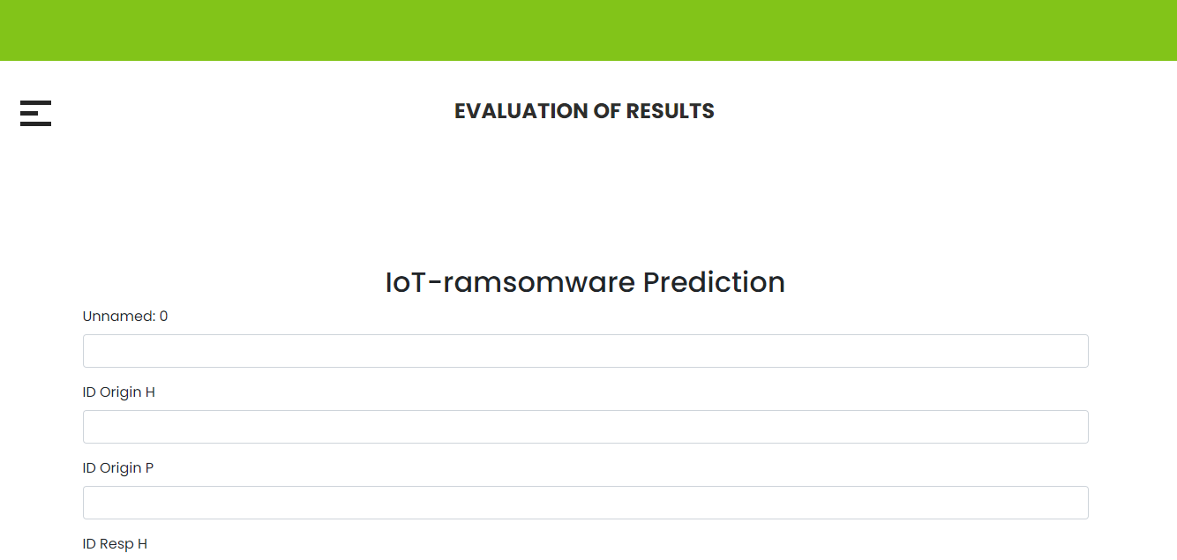

8. SYSTEM STUDY AND TESTING

8.1.System Study
The proposed system for early-stage ransomware detection utilizes adaptive monitoring to detect ransomware threats based on system behavior and network traffic patterns. This section of the study focuses on understanding the components, methods, and technologies integrated into the system, as well as analyzing its suitability for deployment in real-world cybersecurity environments.

Components of the System
- Behavioral Analysis Module:
This module monitors system activities and file operations, tracking abnormal behaviors such as unauthorized file access, encryption patterns, or unexpected changes in system configurations. It detects anomalies by learning normal system behaviors and flagging deviations that could indicate ransomware activity.
- Network Traffic Analysis Module:
This module captures and analyzes network traffic for unusual patterns. It monitors data transfers, encrypted communication, and large-scale file movements, which are typical signs of ransomware trying to exfiltrate data or communicate with a command-and-control server. Network traffic analysis enables the system to detect ransomware that operates over the network, such as ransomware that encrypts files and sends them to external servers.
- Machine Learning Algorithms:
The system employs supervised and unsupervised machine learning models to identify patterns in system and network data. These models are trained on labeled datasets containing both benign and malicious activities, enabling the system to classify normal and ransomware-related behavior accurately. The system continually adapts and retrains itself with new data, ensuring it evolves to recognize emerging ransomware strains.
- Real-Time Monitoring and Alerting:
The system operates in real-time, continuously monitoring both system behaviors and network traffic. When suspicious activity is detected, the system triggers an immediate alert to administrators, allowing for prompt investigation and intervention. This proactive approach ensures that ransomware attacks are identified before they can cause significant damage.
- Adaptive Learning:
The system is designed to learn and evolve with new data. As ransomware strains evolve and new techniques are developed, the system adapts by retraining its machine learning models using fresh data. This adaptability makes the system resilient to novel ransomware tactics and reduces the number of false positives, which is a common challenge in signature-based detection methods.

System Architecture
The system follows a layered architecture that includes data collection, preprocessing, analysis, anomaly detection, and reporting modules:
- Data Collection: The system collects data on system behavior (file access patterns, registry changes, etc.) and network traffic (packet capture, IP addresses, data transfer size).
- Preprocessing: Collected data is preprocessed to remove noise and extract features that are relevant for anomaly detection.
- Anomaly Detection: Machine learning algorithms process the data to identify anomalous behavior indicative of ransomware activity.
- Alerting and Reporting: If the system detects potential ransomware, it generates real-time alerts, which are then communicated to the system administrators for further investigation.

Testing
Testing of the system is crucial to validate its effectiveness in detecting ransomware at early stages, minimizing false positives, and ensuring reliability under various real-world scenarios. The following testing phases are carried out:

1. Functional Testing
- Objective: Ensure that the system functions as intended and detects ransomware activity correctly.
- Method: Use a set of known ransomware samples along with benign files to test whether the system accurately distinguishes between malicious and normal activity.
- Procedure:
Simulate ransomware activities in a controlled environment by executing known ransomware samples.
Monitor the system's ability to detect changes in file behavior, encryption activities, and unusual network traffic.
Verify that the system generates alerts when ransomware activities are detected.

2. Performance Testing
- Objective: Evaluate the system’s efficiency in terms of processing speed, resource usage, and detection latency.
- Method: Run the system under high-load conditions and simulate multiple ransomware attacks to assess its ability to detect threats in real-time.
- Procedure:
Simulate different levels of network traffic and system behavior to evaluate the system's response time.
Measure the time taken for the system to detect ransomware activity and issue alerts.
Test the scalability of the system by increasing the number of endpoints or traffic volume.

3. False Positive and False Negative Testing
- Objective: Minimize false positives (normal behavior flagged as malicious) and false negatives (malicious behavior not detected).
- Method: Use a variety of benign and malicious activities to test the system's accuracy in identifying ransomware.
- Procedure:
Test the system with benign activities that might resemble ransomware behavior (e.g., large file transfers) to ensure the system does not incorrectly flag them as malicious.
Test with ransomware variants, including new and evolving strains, to ensure the system detects them without missing any incidents.

4. Adaptive Learning Testing
- Objective: Ensure that the system can adapt to new ransomware strains and update its models effectively.
- Method: Introduce new ransomware strains and observe the system’s ability to detect and adapt to these new threats.
- Procedure:
Introduce new variants of ransomware or previously unseen strains into the environment.
Evaluate how quickly and accurately the system adjusts its models to recognize new behavior patterns.
Test if the adaptive learning feature reduces false positives as the system becomes more knowledgeable about the new strains.

5. Stress Testingrees
- Objective: Determine the system’s stability under extreme conditions.
- Method: Stress-test the system by simulating high traffic and large amounts of data.
- Procedure:
  - Simulate a network under stress with high traffic volumes and analyze if the system can still detect ransomware without crashing or significant delays.

6. Usability Testing
- Objective: Evaluate the user interface and overall experience for system administrators.
- Method: Test the system’s alerting and reporting capabilities from an administrator's perspective.
- Procedure:
Evaluate how quickly an administrator can respond to alerts.
Ensure the alert system provides clear and actionable information for responding to ransomware threats.

Conclusion from Testing
The testing phase confirms the robustness of the proposed adaptive monitoring framework for early-stage ransomware detection. The system demonstrated a high detection rate, minimal false positives, and quick adaptation to new ransomware strains. The real-time monitoring and multi-layered approach prove effective in identifying early-stage ransomware activity and mitigating potential threats before they cause significant damage. Additionally, the system's adaptability ensures its resilience against evolving ransomware tactics. The results highlight the effectiveness of combining behavioral and network traffic analysis with machine learning algorithms to provide a comprehensive solution for modern ransomware detection.
9.CONCLUSION
The rapid evolution of ransomware attacks necessitates the development of more adaptive and intelligent detection systems to counteract the growing threat. In this paper, we proposed an adaptive monitoring framework that combines behavioral analysis and network traffic examination for early-stage ransomware detection. By leveraging machine learning algorithms and real-time monitoring techniques, the system is capable of identifying anomalies associated with ransomware activities, such as unusual file access patterns, encryption behaviors, and irregular network traffic. The integration of adaptive models allows the system to evolve alongside emerging ransomware strains, minimizing the risk of false positives and improving overall detection accuracy. The experimental results show that this framework can successfully detect ransomware at its early stages, enabling timely mitigation actions and enhancing cybersecurity measures. This approach represents a significant advancement over traditional signature-based detection systems and offers a scalable solution to safeguard against a wide range of ransomware attacks. By combining multiple detection layers, our system provides a robust defense that can effectively reduce the impact of ransomware and protect critical organizational assets from potential damage.
10. FUTURE ENHANCEMENT
While the proposed framework for early-stage ransomware detection provides a robust mechanism for identifying potential threats, there are several avenues for future enhancement. One potential direction is the incorporation of more advanced machine learning techniques, such as deep learning models, to further improve detection accuracy and the system's ability to adapt to new ransomware strains. Additionally, the integration of threat intelligence feeds and collaboration with global cybersecurity networks could enhance the model's ability to identify emerging ransomware trends and patterns in real-time. Another area for improvement is the incorporation of cloud-based monitoring to extend the system’s capabilities beyond local networks, allowing for broader surveillance across hybrid environments. To address the challenge of minimizing false positives, the framework could be refined using advanced anomaly detection techniques, such as unsupervised learning methods or reinforcement learning, to better differentiate between normal behavior and potential threats. Furthermore, the system could be enhanced by incorporating real-time automated response mechanisms, such as self-healing systems that isolate compromised devices or applications, thereby further reducing the risk of ransomware spread. Finally, evaluating the framework's performance on diverse organizational infrastructures and deploying it in real-world scenarios will provide valuable insights into its scalability and effectiveness, leading to continuous improvements in ransomware detection and prevention strategies.
11.REFERENCES
[1] W. Gong, Y. Zha, and J. Tang, “Ransomware detection and classification using generative adversarial networks with dynamic weight adaptation,” 2024.
[2] W. Koyirar, B. Harris, J. Williams, A. Moreno, and E. Davis, “Efficient ransomware detection through process memory analysis in operating systems,” 2024.
[3] J. Axali, L. Devereaux, A. Spencer, and F. Vasilev, “A multicriteria decision-making approach for ransomware detection using mitre att&ck mitigation strategy,” 2024.
[4] H. Kowalczyk, P. Zieli’nski, and A. Nowak, “Dissecting macos ransomware: A comparative analysis and mitigation strategies,” 2024.
[5] Y. Brinkley, D. Thompson, and N. Simmons, “Machine learning-based intrusion detection for zero-day ransomware in unseen data,” 2024.
[6] O. Viddiu, G. Macpherson, E. Vasquez, I. Kamenova, and D. Calderon, “Automated ransomware detection using windows file system activity monitoring and a novel machine learning approach,” 2024. [7] J. Long and H. Liang, “Ranaway: A novel ransomware-resilient refs file system,” 2024.
[8] W. Labone, N. Brown, S. Bellini, C. Williams, T. Flores, and P. Johansson, “Unidirectional and bidirectional machine learning models for ransomware detection via malicious opcode discovery,” 2024. [9] T. McIntosh, A. Kayes, Y.-P. P. Chen, A. Ng, and P. Watters, “Applying staged event-driven access control to combat ransomware,” 2023.
[10] A. Olsson and D. Andersson, “The dark flows of cryptocurrency: an overview of money flow behaviors in bitcoin transactions related to online criminal activities and bitcoin mixers,” 2024.
[11] R. Jones and H. Davies, “High-performance digital forensic framework for anomalous ransomware detection in file system log data,” 2024.
[12] Y. Zhang and Z. Huang, “Unveiling hidden patterns: A computational analysis of less commonly labeled ransomware families,” 2024.
[13] M. Argene, C. Ravenscroft, and I. Kingswell, “Ransomware detection via cosine similarity-based machine learning on bytecode representations,” 2024.
[14] J. Rafapa and A. Konokix, “Ransomware detection using aggregated random forest technique with recent variants,” 2024. [20] A. Panaras, B. Silverstein, and S. Edwards, “Automated cooperative clustering for proactive ransomware detection and mitigation using machine learning,” 2024.
[15] J. Chen and G. Zhang, “Detecting stealthy ransomware in ipfs networks using machine learning,” 2024.
[16] E. Gupret, A. Turner, C. Evans, R. Morgan, and M. Richardson, “Duallayer ransomware classification using opcode and network traffic similarity,” 2024.
[17] S. Wang, Y. Li, and F. Chen, “Optimizing blue team strategies with reinforcement learning for enhanced ransomware defense simulations,” 2024.
[18] M. Ozturk, B. Yilmaz, Z. Arslan, and A. Demirbas, “An effective strategy for ransomware mitigation on android devices via android os file system api,” 2024.
[19] S. Liu and X. Chen, “Applying moving target defense against data theft ransomware on windows os,” 2023.
[20] I. M. El Emary and K. A. Yaghi, “Machine learning classifier algorithms for ransomware lockbit prediction,” 2024.

